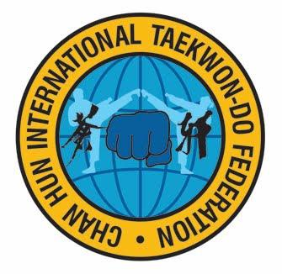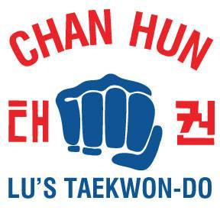
CHAN HUN INTERNATIONAL TAEKWON-DO FEDERATION (CH ITF)
WORLD HEADQUARTERS
2-28 Bentley Avenue Ottawa ON CANADA K2E 6T8
Tel. 1-613-266-5142 itfhq@chitf.org www.chitf.org www.lustaekwondo.com
INVITATION
Dear Colleagues,
On behalf of Chan Hun International TaeKwon-Do Federation (CHITF) and Lu’s TaeKwon-Do, I would warmly like to invite you, your students to join us in celebrating our 2018 June 02 Gen. Choi’s World Cup in Ottawa Canada. You and your students can be a part of this special World Class Championship and attending the International TaeKwon-Do Technical Seminar taking place at the Algonquin College Woodroffe Campus Gymnasium.
The 2018 TAEKWON-DO WORLD CUP has already received the attendance of Canadian Government VIPs, Grand Masters and Masters around the world. As well we will have the participations from Argentina, Spain, Germany, Ukraine, Moldova, China, Malaysia, Nepal, Pakistan, Colombia, Vietnam, Puerto-Rico, Mexico, Dom. Republic, USA and across Canada. This support and level of interest will make this World Cup a very special world class competition.
CHITF Leaders World Conference on Friday June 01 2018 at 2pm and follow by International Black Belts Seminar at 4pm. As well, we will host a Special Celebration Banquet at 8pm June 02 2018.
Please join us the celebration!
Yours in TKD,
Phap Lu, MBA, 9th Dan Organizer

- Please ask your students to visit www.lustaekwondo.com or www.chitf.org for more information. Please be aware registration is ON-LINE ONLY:
- http://tkd-events.com/Events/upcoming-events/tournaments/136-2018-world-cup

